TERCER GRADO- CLASS N°5
SINGULAR PLURAL
It´s a ………. They are …………

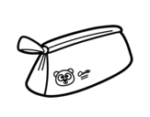1) It´s a pencil case.

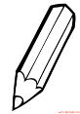 2) They are pencils

HIGHLIGHT THE CORRECT OPTION ACCORDING TO THE PICTURE ( RESALTO LA OPCIÓN CORRECTA CON LA IMAGEN)
3. a) It is a ruler b) They are rulers.

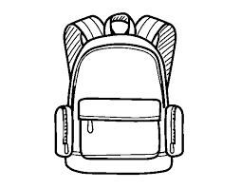 4. a) They are schoolbags. b) It is a schoolbag

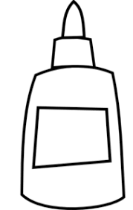 5. a) It is a glue b) They are glues

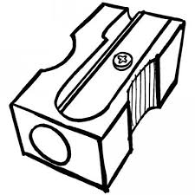 6. a) It is a sharpener. b) They are sharpeners.
7. a) They are books b) It is a book

